What Is velocity?

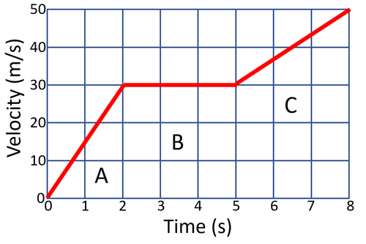
Describe the motion of the object at:
A:___________________________________________________________________________
B:___________________________________________________________________________
C:___________________________________________________________________________

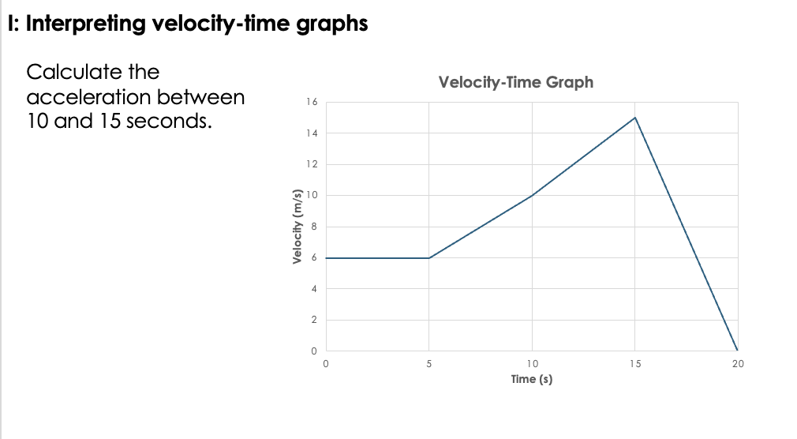
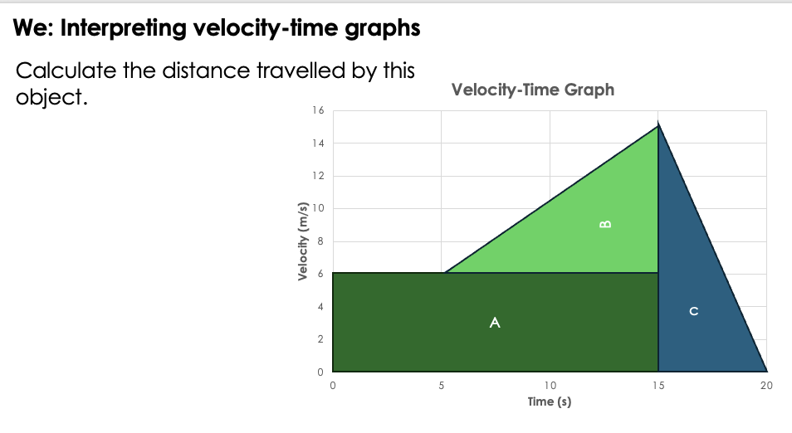
B
Distance =
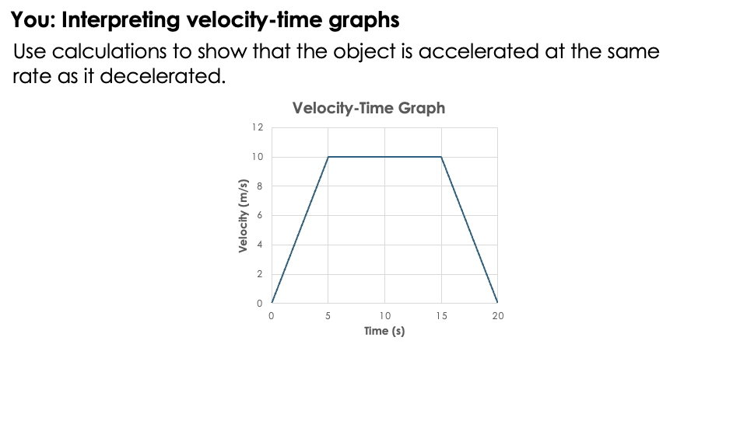
Gradient between 0-5 seconds =

Gradient between 15-20 seconds =

READ NOW: Velocity & Acceleration Date: 2/12/2025
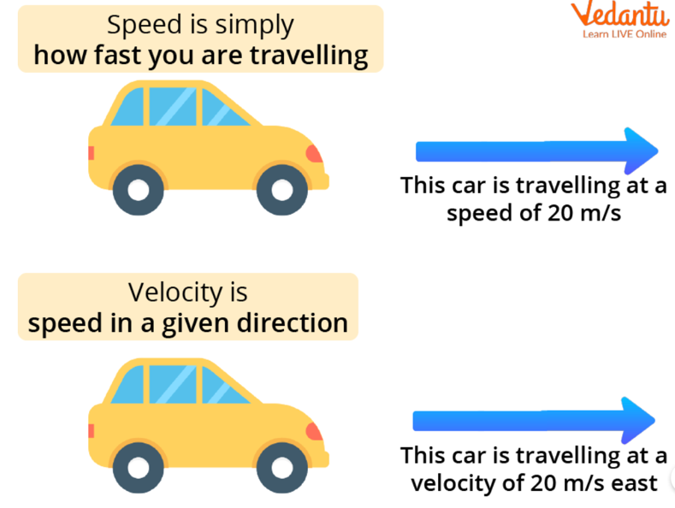
Velocity means speed in a certain direction.
- Speed = how fast something moves
- Velocity = how fast and which direction it is moving in
If the direction changes, then the velocity changes, even if the speed stays the same.
For example, a car turning a corner has changing velocity.

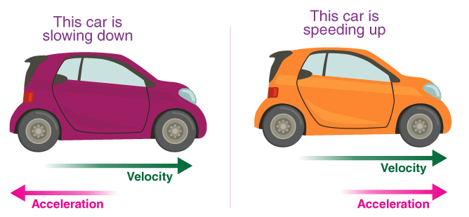
Acceleration tells you how quickly velocity changes.
An object accelerates when it:
- speeds up
- slows down (this is negative acceleration)
- changes direction

Formula:
$$\text{Acceleration}=\frac{\text{change in velocity}}{\text{time}}$$
- Change in velocity = final velocity − starting velocity
- Time must be in seconds
- Units for acceleration = m/s² (metres per second squared)
Questions
- What is the difference between speed and velocity?
- If a car is travelling at 30 m/s north, is this speed or velocity? Why?
- When does an object accelerate?
- A runner slows down from 9 m/s to 6 m/s. Is this positive or negative acceleration?
- A car changes its velocity by 10 m/s in 5 seconds. What is the acceleration?
Velocity-Time Graphs
- State the definitions of:

  - Velocity
________________________________________________________________________________________________________________________________________________________________
  - Acceleration
________________________________________________________________________________________________________________________________________________________________
- Complete the table below by describing the motion shown by each type of line on a velocity–time graph
Velocity-Time Graph
Horizontal line
Positive gradient
Negative gradient

- Describe how to calculate the distance travelled by an object from a velocity-time graph.
________________________________________________________________________________________________________________________________________________________________
- Use the following velocity-time graph to answer the questions.

- Describe the motion of this object between:
  - 0 and 5 seconds
____________________________________________________________________________________________________________________________________________________________________________________
  - 5 and 10 seconds
____________________________________________________________________________________________________________________________________________________________________________________
  - 10 and 15 seconds
____________________________________________________________________________________________________________________________________________________________________________________
  - 15 and 20 seconds
____________________________________________________________________________________________________________________________________________________________________________________

- Calculate the distance travelled by this object during the 20 seconds.

- Use the following velocity-time graph to answer the questions.

- Describe the motion of this object between:
  - 0 and 5 seconds
____________________________________________________________________________________________________________________________________________________________________________________
  - 5 and 10 seconds
____________________________________________________________________________________________________________________________________________________________________________________
  - 10 and 15 seconds
____________________________________________________________________________________________________________________________________________________________________________________
  - 15 and 20 seconds
____________________________________________________________________________________________________________________________________________________________________________________
  - 20 and 25 seconds
____________________________________________________________________________________________________________________________________________________________________________________
  - 25 and 30 seconds
____________________________________________________________________________________________________________________________________________________________________________________

Calculate the distance travelled by this object during the 30 seconds

